# Requirements

**BRAINSTORMING IDEAS**

https://miro.com/app/board/o9J_kjKpWic=/

## Introduction

*The purpose of the requirements phase is to allow for developers to work out what the application should be able to do. It is important to understand what the users would like the application to do rather than the developer deciding what is required.*

*You can write a bit about your project area. Each paragraph has a blank line between it and the previous paragraph*

**What is the name of your game?**

The name of the game we are developing is “Animal Simulator”.

**Briefly explain what the game is about.**

The game

**What game genre does it fall into?**

It has 3 main genres, open world, sandbox, and simulation.

**Is it multiplayer or single player?**

For the meantime, we will keep the game single player because we do not have a lot of time. Multiplayer will require a bit of networking technologies and more coding.

**Briefly describe the game mechanics.**

The main

**Briefly describe the style/design/graphics.**

We will be using low-poly graphics because they aren’t that graphics intensive and they look very nice to look at. The styling of the art has less polygons and they are grouped in a mesh together forming a cartoonish look with different shapes. Pastel colours, deep blacks, and vibrant colours well with this type of artwork.

**Does it have a story?**

It doesn’t have a story because usually sandbox games focuses on independence, freedom, creativity, and the gameplay.

**What kind of quests/objectives the player can do?**

The game has objectives and unlockables, so it will give the player some sense of achievement and something to chase for. For example, if you get certain amount of points there is a text on the screen that will compliment and praise the player. The player will be able to get new skins or a new animal.

## Requirements gathering

### Similar applications

*Look at and document three similar applications. Be sure to include the following for each:*

* *Descriptions*
* *Advantages*
* *Disadvantages*
* *Screenshots*

**Description of the game:**

REFERENCE: https://store.steampowered.com/app/265930/Goat_Simulator/

Gameplaywise, Goat Simulator is all about causing as much destruction as you possibly can as a goat. It has been compared to an old-school skating game, except instead of being a skater, you're a goat, and instead of doing tricks, you wreck stuff. Destroy things with style, such as doing a backflip while headbutting a bucket through a window, and you'll earn even more points! Or you could just give Steam Workshop a spin and create your own goats, levels, missions, and more! When it comes to goats, not even the sky is the limit, as you can probably just bug through it and crash the game.

**Advantages/Likes:**

E.G. Talk about UI, Game Mechanics, Graphics, Level Design, Story, Multiplayer, Gameplay, Sound, AI, Replayability

I really like the User Interface and its colours.

**Disadvantages/Dislikes:**

E.G. Talk about UI, Game Mechanics, Graphics, Level Design, Story, Multiplayer, Gameplay, Sound, AI, Replayability

**Screenshots:**

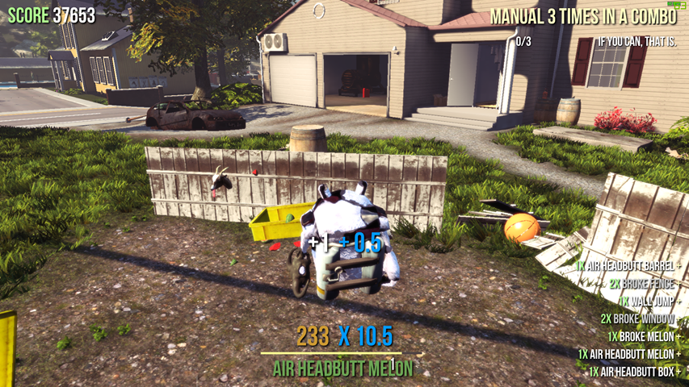

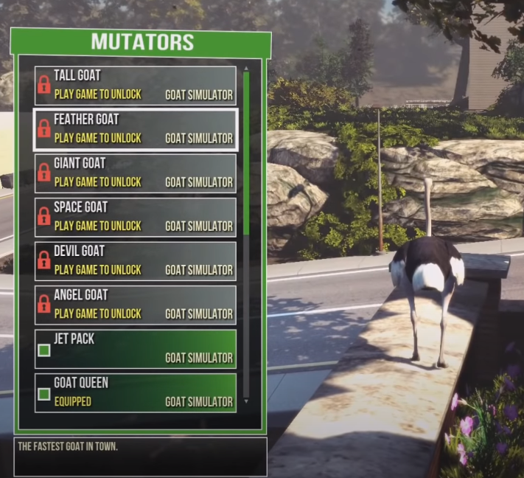

**Description of the game:**

REFERENCE: https://store.steampowered.com/app/376210/The_Isle/

The Isle is intended to be a gritty, open-world survival horror game. Explore vast landscapes of dense forest and open plains, traverse treacherous mountains, and wade through dark swamps where horrors lurk. Hidden within are ruins that hold insight as to what came before. Through it all, keep in mind there is only one goal: survive

**Advantages/Likes:**

E.G. talk about UI, Game Mechanics, Graphics, Level Design, Story, Multiplayer, Gameplay, Sound, AI, Replayability

**Disadvantages/Dislikes:**

E.G. talk about UI, Game Mechanics, Graphics, Level Design, Story, Multiplayer, Gameplay, Sound, AI, Replayability

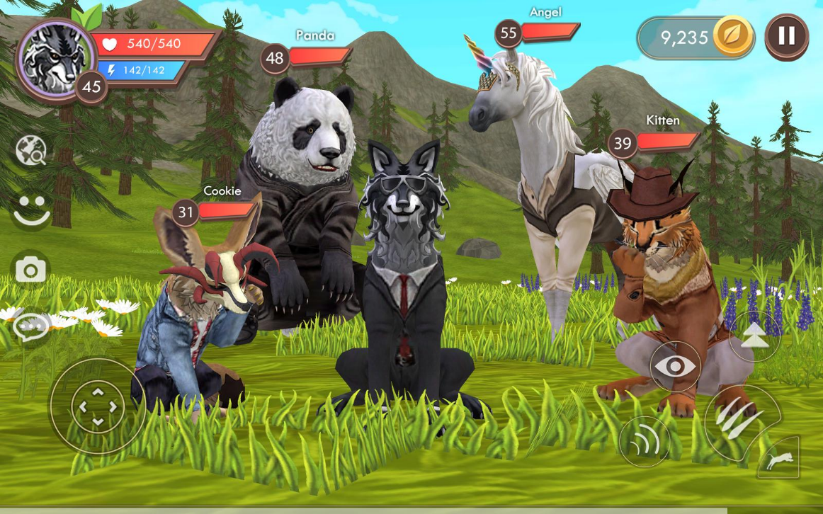

### Personas

These are fictional characters to help the developer understand the users’ needs. They also help identify who the relevant users are.

For reference and to get ideas:

<https://medium.com/@fernandocomet/the-player-persona-template-d171e3e0c05d>

<https://www.myersbriggs.org/my-mbti-personality-type/mbti-basics/judging-or-perceiving>

This website was used to create personas:

[https://www.hubspot.com/make-my-personahttps://assets.weforum.org/editor/large_f521kcO6KWMHIuWbejh1UG8FKygKJkKiwUY4FLtotsg.JPG](https://www.hubspot.com/make-my-persona)

**What type of gamer are you?**

**Cheaters**

**Achievers**

**Explorers**

**Social Gamer**

**Competitive Gamer**

**Completionist Gamer**

**Persona 1:**

**Persona 2:**

**Persona 3:**

What kind of player are you?

I like bein the hero and do the good things, but not because you have to do them by law

If nobody gets hurt I don't to follow the law

I don't want to enforce rules on anybody

I don't compete in games, I am being cooperative

I like to build a lot of things

I like long games

I like most games that has good replayability and make your own stuff

Motivation:

What motivates you

Gender Male

Age 25

Status Single

Job Title Working for McDonalds

Industry Retail, fastfood

Location Wicklow

Gamers for OpenWorld Sandbox Games

Personality:

Extrover Introvert 4

Sensing Intuitive 4

Thinking Feeling 1

Judging Receiving 4

### Interviews ✓ 9/10/2020

Conduct interviews with 3 or 4 users to find out what the important features for them for the app are. There may be various issues that arise in multiple interviews. These can be grouped together into several themes.

We asked 2 other classmates who are developing a fps parkour game.

Questions 1:

Answer:

### Survey ✓ 12/10/2020

You can create a questionnaire and use the results of the questionnaire as a basis for finding out requirements.

Finding out the requirements for our game:

<https://forms.gle/NBuTSXrZnVfgFXjN8>

Finding out the target audience + creating personas:

https://forms.gle/a7r6WCRBq3PgQ4Uv9

## Requirements modelling

### Functional requirements

Create a numbered list of what the application should be able to do. Start with the most important feature.

TOP 10 Features + brief description:

1. Sandbox:
2. Open World:
3. Points System:
4. Choose your animals:
5. Visual descriptions:
6. Stats:
7. Game logs:
8. 3rd person:
9. Collectibles:
10. Achievements:

### Non-functional requirements

These are requirements which if not met do not stop the application from working, but which mean that the application is not working as well as it should. They are usually based on issues such as:

* Usability

**Talk about potential bugs and problems (make references to the other games)**

asdadsad

* Performance

**Talk about performance requirements.**

Smoothing asdadad

**Is it resource intensive?**

We are aiming to make it playable for mid-range gaming PC

**What platform will it run on e.g. mobile/pc?**

PC asdadsada

* Security

**Will it require user credentials?**

You can enter your name

**Is there a login system?**

No asdasda

**Is there auto-save and where will it be saved?**

Yes asdsadia

### Use Case Diagrams

Consists of actors and use cases. You should document each individual use case.

??????????????????????????????????????????

## Feasibility

This section describes which technologies are planned to be used in the development of the application. It then explains if there are any issues in terms of the technical feasibility of the project, for example, if there are two different types of software which may have compatibility issues.

TOP 5 TECHNOLOGIES:

1. Unity for game development:

asdaasdasdasd

1. Visual studio code for coding:

asdasda

1. Miro for brainstorming:

asdasdasd

1. Trello for project management:

asdadasda

1. Photoshop for designing:

asddsadsa

1. Possibly blender:

asdasdadasds

## Conclusion

Write a couple of paragraphs summing up the chapter. Explain what area your project is about. Describe what the chapter has discussed.

??????????????????????????????????????????

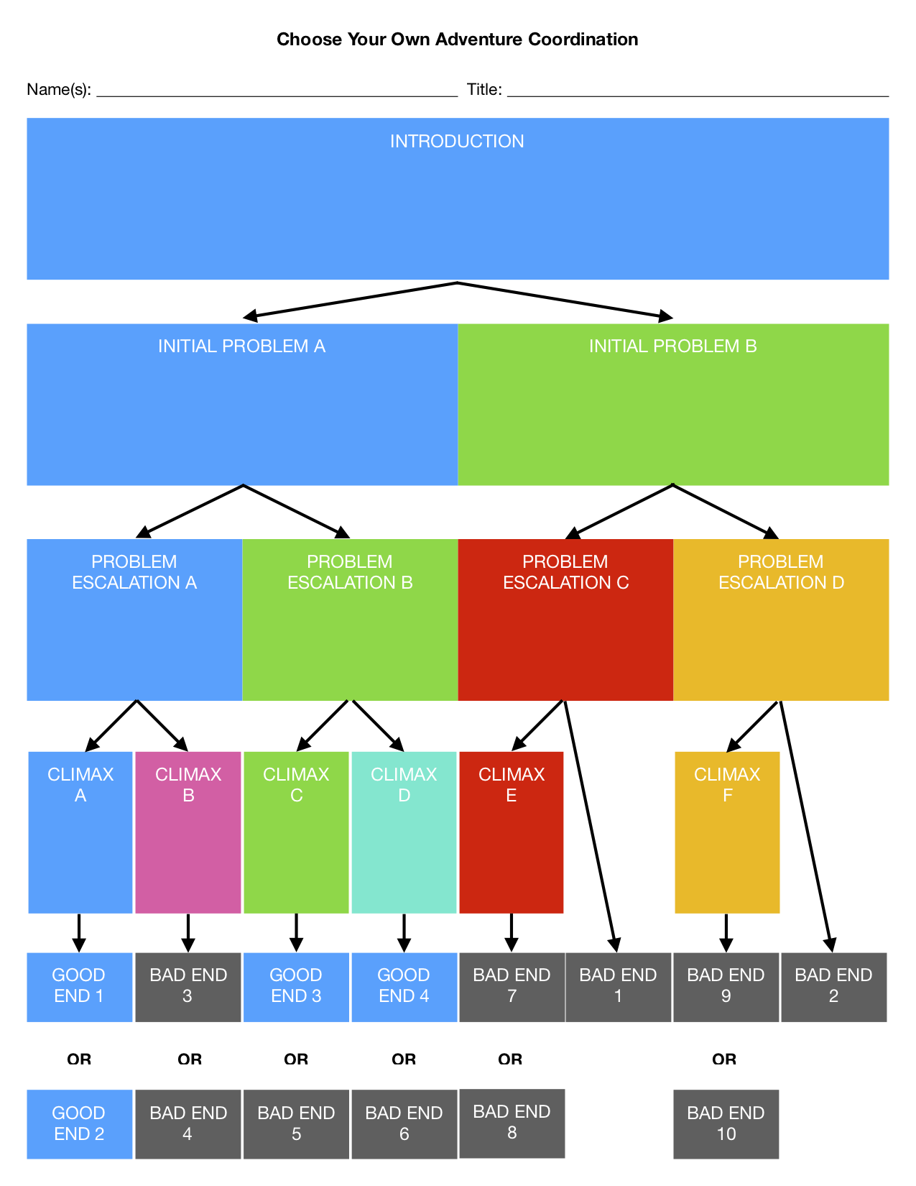

Figure https://braveintheattempt.com/2017/10/30/google-forms-game-based-learning/